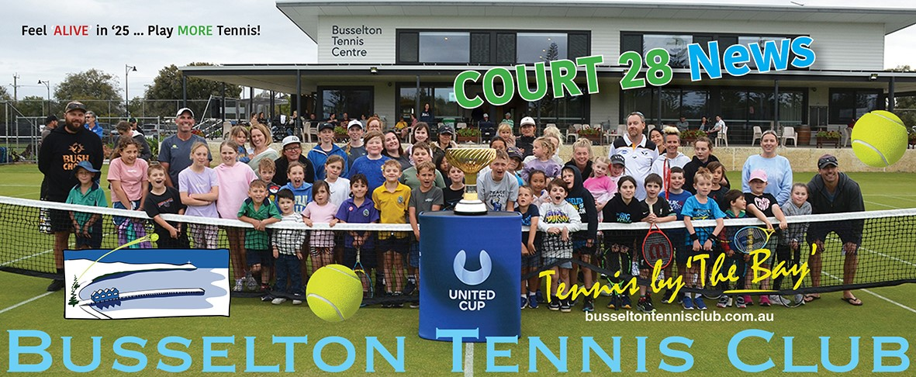

**Hi there, a quick note from your scribe ….. Happy New Year to all members and their fabulous families! Reader beware, the newsletter is lengthy however contains some very important information, and some not so important visuals in closing pages. Thank you for taking the time to keep current with club happenings, especially as we prepare for our major events coming up over next few months.**

**Event coordinators are now calling for member support. Just pop your name on the lists on the Noticeboard.**

**Edition 6**

|  |
| --- |
| COMMITTEE REPORTS |

|  |
| --- |
| PRESIDENTS REPORT |

I hope you all had an enjoyable Christmas and welcomed the New Year in with vigour.

The B.T.C. has two major events coming up soon and we are also hosting a new Junior event. We can all be proud of Busselton Tennis Club, let’s continue to show the way when it comes to showcasing our club, our grounds and most importantly our renown hospitality.

* 26th – 29th January - Busselton Toyota Junior Tournament, run by Tennis West with 28 events / 129 entrants.
* 1st – 3rd March - March Tournament with 13 events / 48 sections/ 348 players which is very good.
* 23rd March –South West Regional Junior Tournament – Inaugural tournament

These events require the kitchen and bar facilities, this needs MANY volunteers. Lists are on the notice board for these events, so I encourage people to put their names into volunteer.

We will continue to strive and retain Busselton Tennis Club as the premier Tennis Club in the South West, I and the management thank everyone for their help in this regard.

Another very important event in the next 4 months is the A.G.M. There is several management committee retiring from the board there will be a need to fill these places.

I encourage members to step up and fill these positions, so please give it plenty of thought, if they are not filled the club will not function, and the club is vibrant and operating extremely well.

I wish everyone great and enjoyable Tennis and a good time socializing at Court 28. Wayne Richter

|  |
| --- |
| CAPTAINS REPORT |

Ladies Gala Day 13th February 2025. Play begins at 9.30am sharp! Nomination of $25 includes morning tea and lunch.

Enter with or without a partner, should numbers prevail we will offer 3 divisions. Nomination list on Noticeboard or email Wendy or Merryl [captain@busseltontennisclub.com.au](mailto:captain@busseltontennisclub.com.au)

Busselton Toyota Junior Tournament 26th – 29th January. We are pleased to host 129 Junior player and their support families for this event.

March Tournament 1st – 3rd March. This is a very popular event; our Tournament Director Jan Button was very very surprised how quickly events closed. BTC will be hosting 348 players and their support crews.

We are calling upon our Volunteers and Club members who are yet to fulfill their discounted Membership fee commitment to put their names up on the Bar and Kitchen rosters for the Junior Tournament and likewise for the March tournament come February. Get in early to select your time. Volunteer enquiries to Wayne [president@busseltontennisclub.com.au](mailto:president@busseltontennisclub.com.au) or Merryl [captain@busseltontennisclub.com.au](mailto:captain@busseltontennisclub.com.au)

Club Office Duty We are calling for members to assist in the Match Office either at the desk or on the computer. We are happy to train members for both roles, see Merryl at the Captains desk

Saturday Afternoon Tea Duty. The ladies coordinating Arvo Tea’s would love your help, please your name on the Saturday Afternoon Tea roster on the noticeboard or see Barbara Weeks.

Upcoming AGM The Captains role will be vacated at the upcoming AGM in May. We have had some good feedback this season, we have also had several people come forward feeling a little disgruntled and looking for change.

If you are seeking change, have new ideas, want to review current playing formats offered then now is the time for you to put your hand up. As Captains we are happy to chat now and offer our support as you transition into the role.

Court Bookings Should you play outside clubs scheduled tennis, you MUST book a court on line, link [COURT HIRE | BusseltonTennisClub](https://www.busseltontennisclub.com.au/court-bookings-1). If you need assistance to book a court, please reach out.

Bomaderry (NSW) Tennis Representatives will be visiting the southwest and playing tennis at the Busselton Tennis club 27th -31st March. This is reciprocal event coordinated by Yves based on our local lads visiting Bomaderry last year. Program is yet to be confirmed, however they will be team’s tennis, players will be joining social tennis on Saturday and of course Court 28 time.

15th March - Get out the green, orange and white flags, soak up some Guiness or Jamison , nab a leprechaun for a good joke or two and prepare yourself for some great Irish food and festivity as we celebrate St Patricks day

|  |
| --- |
| FUNCTIONS REPORT |

Since our last edition in December, Functions has been kept busy organising the following events at BTC:-

* GeoCatch community info session
* GMAS staff Christmas party
* Christmas Fun: sponsored by Kevin and catered by Functions Catering
* Christmas raffle: organised by Maureen for Functions
* 40th birthday party
* Funeral Service and Wake – 100 people – Functions Catering. Many thanks to Bernie A, Merri, Barb, Noelene, Vicki for helping me in the kitchen and/or cooking delicious food.

We are getting great reviews about our venue and how it is perfect for holding so many different events.

**“Op Shop Glam” soiree** - Ladies, save the date. The BTC Southwest League ladies are hosting a “Op Shop Glam” soiree, Saturday 5th April. We have a small working group convening to coordinate event. This event will be bigger and better than our last successful event. Start your Op shopping to get glamoured up, dial in some friends and get them to save the date. It will be quirky and loads of fun.

Information will be forthcoming via club Communication email, social media and Team Captains

|  |
| --- |
| CLUB CALENDAR |

* **26th – 29th January - Busselton Toyota Junior Tournament**
* **6th February - Thursday nighters reconvene**
* **7th February – Sponsors Day**
* **15th-16th February- Men’s and Ladies Doubles Championships**
* **13th February – Ladies Gala Day**
* **14th February - Have A Hit Fridays reconvene for Term 1**
* **1st – 3rd March - March Tournament**
* **15th March – St Patricks day Irish dinner**
* **15th – 16th March – Mixed Doubles Championships**
* **20th March – Southwest League Ladies Pennants grand final**
* **23rd March – Southwest Regional Junior Tournament**
* **27th March – 31st March – Bomaderry NSW visiting**
* **5th April – Ladies – Op Shop Soiree**
* **5th-6th April – Singles Championships**
* **1st -29th May – Sanderson Women’s Competition starts**
* **May – date to be confirmed – AGM**

|  |
| --- |
| VOLUNTEER COMMITTMENT |

**Volunteers do not necessarily have the time, they just have the heart** (Elizabith Andrew)

Its time again to thank our dedicated Volunteers who time and time again step and support our club at our many events, functions and from an operational perspective.

We are grateful, we are thankful, and you are appreciated.

|  |
| --- |
| PROGRAM REPORTS |

|  |
| --- |
| COACHES CORNER |

See Flyers at end of Court 28 News for all coaching options for adults and juniors

|  |
| --- |
| SOUTHWEST WOMEN’S LEAGUE |

The Southwest Tennis League is currently in recess, reconvening 20th February.

We wish all teams every success as they transition into the latter part of the SW League season of course the Grand finals set for 10th April

Don’t forget, Busselton Tennis Club will offer Sanderson Cup for ladies wishing to play competitive teams tennis once SWL Grand finals are complete. Give this some thought, chat to your team and opposing teams, the more playing the better the event. It is a significant event founded and supported by club stalwart Di Sanderson

We look forward to seeing you all back on the court. Any queries, please contact Michelle [mvdkroft@live.com.au](mailto:mvdkroft@live.com.au)

|  |
| --- |
| THURSDAY ARVO SCROUNGERS |

If you fancy structured tennis, which is very competitive, however is all about the camaraderie and the love of the game.

These lads enjoy the game and a visit to Court 28 for the odd refreshment

If you wish to join the lads on a Thursday arvo reach out to Steve by email [stevemail@icloud.com](mailto:stevemail@icloud.com) , he can show you the way

|  |
| --- |
| THURSDAY NIGHT MIXED |

The Thursday night tennis comp is currently in recess. The next season is scheduled to start on 6th February (and runs for 9 weeks)

For those that interested the night starts from 7pm & involves the playing of 3 sets (1 singles & 2 doubles).

This competition embraces a wide range of playing standards and can accommodate everyone from enthusiastic beginners to experienced players.

Nominations are open for the next season. You can nominate as a regular where you play each week. You can also nominate as an extra where you can nominate week to week.

Nomination is via email to [jandamc86@gmail.com](mailto:jandamc86@gmail.com)

|  |
| --- |
| JUNIORS |

**HAVE A HIT FRIDAYS ARE BACK**

I’m thrilled to announce that HAH Fridays will re-commence on **February 14th**, marking the return of one of our most important and beloved programs for the Junior Club. This initiative not only provides a fun and engaging environment for our young players but also helps foster a strong sense of community and connection within the club.

**What is HAH Fridays?**

HAH Fridays (Have a Hit Fridays) is a weekly program designed to give our junior members an opportunity to develop their skills, make friends, and enjoy tennis in a relaxed and social setting. HAH Fridays create an inclusive atmosphere that encourages participation at all levels of ability.

**How Can You Help?**

To make this program a continued success, we need **your help!** We’re seeking volunteers to assist with:

* **On-court support**: Helping with games, and providing guidance
* **Player Registration**: Welcoming Juniors and parents, obtaining details and providing general information
* **Food Prep for BBQ**: Helping in the kitchen preparing rolls and assisting with clean-up after the Sausage Sizzle
* **In the Bar**: Taking player registration/Sausage Sizzle fees and serving drinks and nibbles to parents **(**RSA required**)**

Whether you can commit to a single Friday or join us regularly, any amount of time you can spare will make a big difference. No previous experience is required—just a willingness to lend a hand and support our juniors.

**Why Volunteer?**

Volunteering at HAH Fridays is a rewarding way to:

* Give back to the club and support the next generation of players.
* Meet other members and families in the Busselton Tennis Club community.
* Share your love of tennis and help inspire young players.
* Earn a warm smile and endless gratitude from our juniors.

**Sign Up Today**

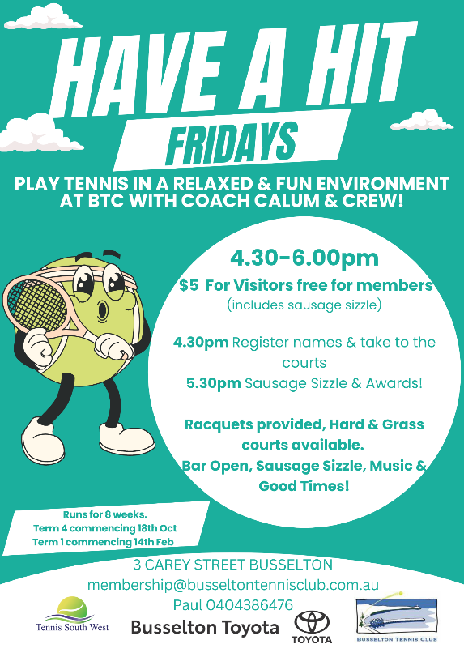If you’re interested in volunteering or would like more information, please contact Graeme Bracken (Junior Club Co-ordinator) or place your name on the 'Volunteer List' on the Junior Club noticeboard. Together, we can ensure that HAH Fridays continue to thrive and bring joy to our young players.

Thank you for your ongoing support, and we look forward to seeing you on February 14th to kick off 2025 HAH Fridays!

|  |
| --- |
| SOUTHWEST REGIONAL JUNIOR TOURNAMENT – NEW INITIATIVE |

The Busselton Tennis Club is proud to host this inaugural Tournament on Sunday, March 23rd. This exciting event promises to bring together some of the region’s most talented junior players for a day of thrilling matches and friendly competition.

The tournament will feature singles and doubles for 12 and under juniors, providing an excellent opportunity for our young players to showcase their skills. Matches will kick off early Sunday morning, with the finals scheduled for the late afternoon. Spectators are encouraged to come along and cheer on these rising stars of tennis.

Food and refreshments will be available to competitors throughout the day.

Volunteers are needed to help make this event a success. If you’d like to assist with court setup, scoring, or in the clubhouse, please contact the Junior Club Coordinator Graeme Bracken.

Let’s come together as a community to support our junior players and celebrate the spirit of tennis. We look forward to seeing you there.

|  |
| --- |
| PICKLEBALL |

What is PICKLEBALL? One of the fastest growing sports out there is the answer. But why...

Using a paddle (kind of like table tennis) & a wiffle ball (a scaled back version of a baseball), you compete on a court (similar to tennis) & score points to win the game using tactical shots, patience, and easy to learn strokes.

It's generally considered easier than tennis, due to its smaller court size, lighter equipment, and simpler rules. The reduced court dimensions make movement less demanding, while the lightweight paddles & plastic balls contribute to a more accessible learning curve.

It's just a really fun sport suitable for all ages and abilities and encourages inclusive play.

It’s great to see 24 players regularly taking the courts on Tuesday and Thursday evenings for organised play 6-7.30pm , alternatively Friday evenings at 6pm and Saturday morning 9am

Social membership of $50 is offered to Picklers, which entitles play for $5 per session. Want to know more – contact Ken Madden

|  |
| --- |
| THE A TEAM, THE B TEAM AND GARDENING GURU’S |

Gardens and club surrounds are looking awesome. Clubs B Team busy bee in the gardens has not gone un-noticed, as with Kim’s clipping, chopping and finessing of the Cactus gardens. Also, thanks to Macca for our balcony geraniums. Good job everyone.

|  |
| --- |
| CORRECT COURT ATTIRE |

Our courts are looking fabulous, and as we are about to host Busselton Toyota Junior Tournament and soon after the March Tournament, we remind our members that if there is no net there is no play and to please be mindful of your choice of footwear. Incorrect shoe tread will damage our courts very quickly. If you have a questions, please see Wendy or Merryl.

|  |
| --- |
| BUSSELTON TENNIS CLUB CHRISTMAS SUNDOWNER |

What a great event with 90 off members, patrons and friends enjoying Busselton Tennis Clubs hospitality. The event was a fun day, the after-tennis celebration had a great vibe. All Court 28 refreshments & tasty finger food being supplied by Kevin Wren additional to his sponsorship from City Discount Tyres.

Wow! how's that for generosity? ... and it wasn't the first time this quiet supporter of our club has shown such amazing support.

Kevins dedication to our club sees him drive the round trip Waroona-Busso & back two times a week to be a part of BTC's Tennis by 'The Bay' .. Thanks Kevin, thanks to the social committee and volunteers

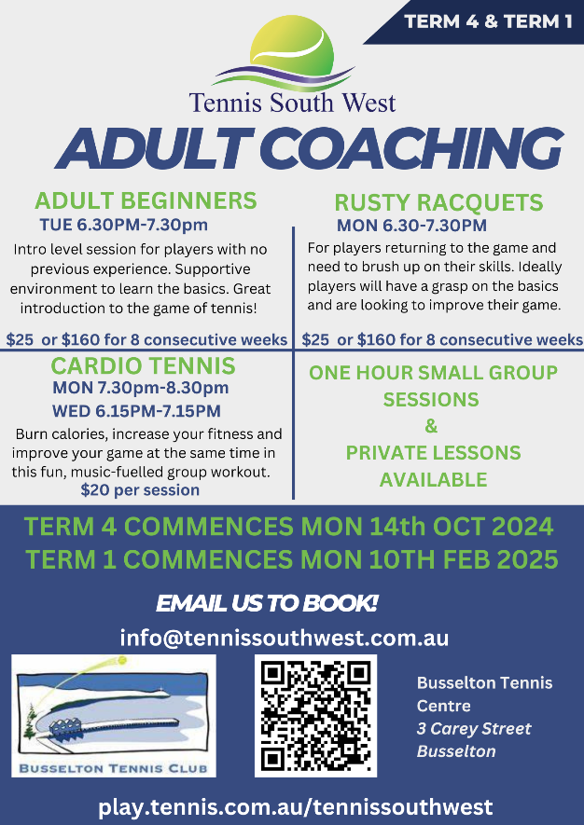

|  |
| --- |
| TENNIS SENIORS ADELAIDE TEAMS CARNIVAL |

The 5th of January 2025 several players from Busselton Tennis Club crossed the border to Adelaide to play in the [Tennis Seniors Australia National Carnival in Adelaide](https://www.tennis.com.au/wa/news/2024/07/19/tennis-seniors-australian-national-teams-carnival-in-adelaide)**.**

**This** Carnival sees friendly competitive interstate rivalry, with a blend of social engagement which was embraced

by Merryl, Wendy, Rosa, Vannessa, Tracy, Sandy, Leonie, Grace, Erica, Paul C, John Mc, Macca and Michelle V.

The weather gods played very fair delivering playing days between 25 and 30 degrees, the WA dinner was a great opportunity to meet other WA players and reacquaint with old tennis buddies from years gone by.

The Adelaide City hospitality was at a high level, easy access to venues, the city centre and restaurants, spoilt for choice re food and wine, hardest decision was where and for how long!

Paul Collins and Johnny Mc’s team playing in the 70-75 Division 1 was a combo team of Busselton /Bunbury and Mandurah. They quietly edged their way to a final and surprised themselves and bewildered a highly fancied Adelaide opposition winning the final

Rob Phillips, Johnny Mac, Paulie, Kevin Dingle, Linton Bowen, Russell Lazenby

Tracy Adams, Sandy Sigelski combined with

Zelieka Cahill and Karen Stewart from

Dunsborough and Colleen Wright from Bunbuy,

in a team of 5 aptly called “Servivors” ….

The tennis was great, our opposition fair

and fun, safe to say our off court social

activities were awesome…..t’was great to

have support from our fellas …..And yes,

we brought home the medals as well,

winning 60+ Div 2 event, now the chat

of trundling off to the Gold Coast next year

Quick dip at Glenelg

Out n about with Bullcreek ladies

Leonie Don, Grace Bassett, Carolyn Stokes, Leanne Mattaboni from Busso

club and Mandy Simonetti from Dunsborough club played in 50- 55

division and game across very strong competition, particularly the Queensland team. With the tennis being tough they diverted their

attention to social shenanigans and were the cheerful and best dressed teamies attired with short suits for their social Activities.

Most photographed team of the carnival 😊

Mix n match with Bullcreek girls

Carolyn, Leonie,, Gracie, Mandy, Leanne – best dressed team

Macca’s team was called Mighty Maestro’s, played in the 80+ division

and came a credible runner up in their division losing to NSW in the

final. Macca rounded up enough players over 80😊 to make up a team

, an achievement 😊, it would be fair to say these chaps still know

their way around a tennis court!

Alan Morcombe , Macca ,Ken Adams , Gordon Gregory, Henry Michael , Gerry Hofmann

Michelle Van der Kroft played

with the Bullcreek girls (her Perth

club of old) and Janie from

Dunsborough. This team was

also very competitive missing out

on 4th place by a Bees whisker,

they too found plenty to do off

court around Adelaide city

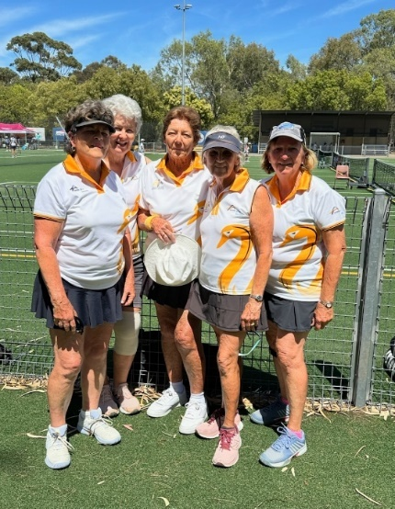

Wendy Weir, Merryl Peet, Rosa, Vanessa Scott and Nikki Morcombe represented WA in the 70–75-year-old group.

They proved to be Busso gnarly n strong, playing all their matches with 4 players due to injury. Nikki as you would, scheduled a hip replacement post tournament, and why she played every match happy to wear the old hip out …bravo Nikki.

Kudos, this team just missed the medal, being placed second to the other WA team in their division…Back in the day they bred them tough 😊

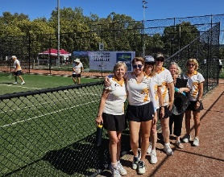Erica Franklin travelled with the Hensman Park ladies, played in over 50s years age group.

Good result, coming 4th in their division

It’s no surprise when you travel there is chit chat…. where are you from, where do you play…..Let’s guess you will not be surprised that many of the players know of our club, sung praises for our courts and facilities, we are really very lucky to belong to a premier tennis club hey!

Congratulations to the medallists, Busselton Tennis club was well represented at the championships and were acknowledged by other teams as being friendly and fair. To the players from predominantly Dunsborough and Bunbury who joined our club players to make up local” teams thank you, you are welcome at our club anytime.

*How can you be standing behind your friend,*

*while they are also standing behind you?*

