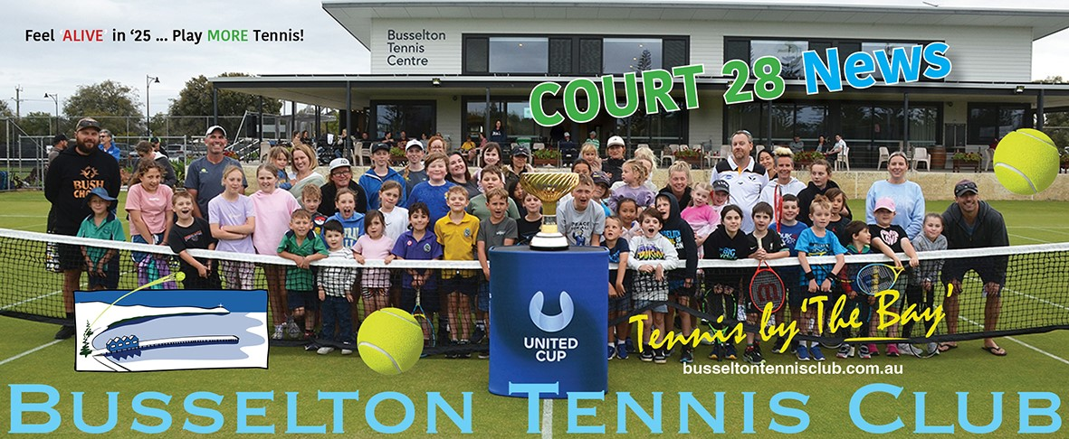

Hello to you …..

Go us! We have coordinated a social and competitive action-packed schedule over the past 2 months, lets acknowledge Wendy and Merryl for delivering a great Gala day that saw 72 women from Southwest Clubs participate, also kudos to Tarryn and her team for coordinating a fabulous and fun Corporate Day which was complimented by all the sponsors attending. We have witnessed another successful Junior Tournament which saw 129 talented young players take the court plus their supporting families who enjoyed our club’s hospitality and vista.

We are not done just yet, we get to show case Busselton Tennis Club again from 28th Feb to the 3rdst March for our highly regarded March tournament. This event closed out in record time with waitlists. This year we present 13 events / 48 sections which see’s competitive tennis offered to 348 players. This year the tournament commences on the Friday with 4 days of court action.

We also have the Mixed Doubles Championships and Singles Championships just around the corner, be sure to get your name up on the noticeboards. Ladies, please don’t be shy there are plenty of chaps looking for partners. Have a chat to Merryl or Wendy who will look after you.

It seems very appropriate now to acknowledge the volunteer task force that ensures that Busselton Tennis Club facilitates all events to the highest standard, this includes the Kitchen helpers, A and B Teams, Bar Staff, Gardening guru’s and our committee.

In closing, this is the Members Newsletter and the content can be driven by you. If you have a good news “story” that you would like to share, please reach out to [tracy.adams@westnet.com.au](mailto:tracy.adams@westnet.com.au) , your input would be most welcome.

The intent of Court 28 News is to share information to our membership group, to keep all informed of club happenings, of new initiatives and opportunities. A big thanks to those who are writing reports or sharing information to contribute to Court 28 News.

Tuesdays nights are BTC’s social nights, 6pm start - just in time for those fabulous sunsets …… so if your racket has gathered a bit of dust over

the past couple of years, your tennis balls are ‘outta puff’ or your strings need a “ping” give this a go … [captain@busseltontenniscluib.com.au](mailto:captain@busseltontenniscluib.com.au)

|  |
| --- |
| **COMMITTEE REPORTS** |

|  |
| --- |
| CAPTAINS REPORT |

**EVENTS ROUNDUP**

* LADIES GALA DAY - saw 72 ladies from the Southwest participate. A perfect day for tennis, competitive play followed by a lunch as all players from clubs mingled and enjoyed our hospitality.

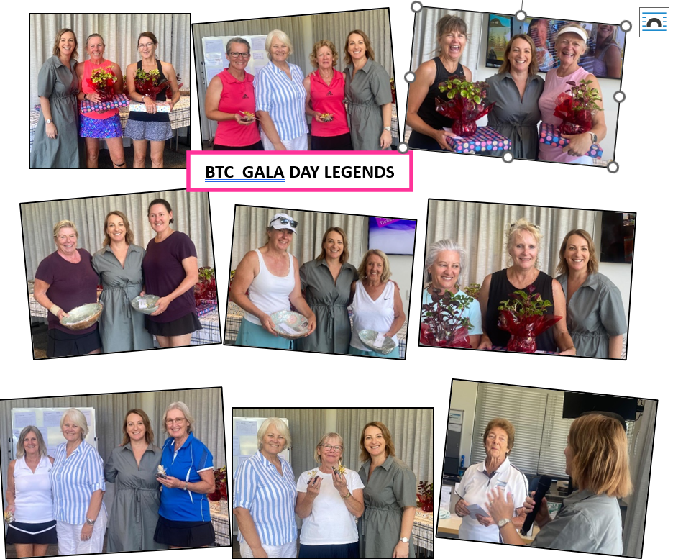

* LADIES AND MEN’S DOUBLES CLUB CHAMPIONSHIPS – The results were:
* Men’s Doubles Championship winners Brycen Godfrey and Miles Armstrong with Runners Up Nic Hay and Jeremy Lloyd 6/2, 6/2
* Men’s Championship Doubles Plate winners Ash Johns/Calum Macaulay with Runners Up Cameron Powell/Bryn Silke
* Ladies Doubles Championship winners Tracy Adams and Sandy Sigelski with Runners up Wendy Weir and Jodie Ganzer 6/1 6/4
* Men’s over 65 doubles winners were Cliffe Silk and Graeme Watson, with Runners up Greg Hooper/Kevin Wren

CLUB CHAMPS MIXED - Please get your names up on the board BY Thursday 13th March for the Mixed Doubles (15th & 16th March)

Entry Fee - Gold members - $5 Silver members - $10

CLUB CHAMPS SINGLES - 22nd & 23rd March.

If numbers are high for these events some 1st round matches may be played 4pm on the Saturday.

These events are for all club members and we encourage you to enter. Not all players will be successful in their first round so we will offer a repo-charge event or plate event ensuring you get plenty of tennis.

|  |
| --- |
| FUNCTIONS REPORT |

**Corporate Day Feb 7th:** well done to Taryn for organising a most enjoyable day for our Sponsors.

Many thanks to Functions Catering team members for assisting me with providing and serving the finger food: Bernie A, Noelene U, Grace B, Suzie S, Vicki D. Sushi from our sponsor Tora Sushi and Noelene's sausage rolls were the food hits of the day.

**Surprise 75th:** Our venue hirer did a wonderful job of keeping her husband's party a secret. He was so surprised when he arrived and realised the party was for him. A great night.

**Dates to note:-**

Tuesday March 4: from 12pm: carpet cleaning

Friday March 7: from 8am: Chris Roe cleaning windows - thanks Chris

Saturday March 8: wedding reception at BTC - no social tennis

Sunday March 9: 2pm: normal social tennis, just a day later and just as much fun

Saturday March 15: 6.30pm: St Pat's Dinner: everyone invited to come along and have a load of fun. Organised by Irish Kathryn and her mate Merryl. Tickets on sale soon.

Saturday April 5: Ladies Op Shop Glam: a night full of fun and laughter. Time to start looking for your glam attire. More info soon.

A new order of BTC caps has arrived: white, dark blue or grey: same price ($17): ask at the office

|  |
| --- |
| MEMBERSHIP SNAPSHOT |

|  |  |  |  |  |  |  |
| --- | --- | --- | --- | --- | --- | --- |
| Gold | Silver | Volunteer disc. Gold & Silver | Junior | Social inc Pickleball | Life | Total |
| 106 | 63 | 89 | 77 | 70 | 8 | 324 |

|  |
| --- |
| **PROGRAM REPORTS** |

|  |
| --- |
| COACHES CORNER - see Jeremy’s images released with newsletter |

Term 1 is back! It's fantastic to see our hot shot juniors returning and growing their love for the sport. They're developing their skills in the program, which includes red, orange, and green ball players from Tuesday to Friday and we have started a new Blue Ball Monday session for 3-4-year-olds.

**Squad Sessions:**

* **Yellow Ball Squad**: 16 kids every Monday night.
* **Green Ball Squad**: 10 kids every Wednesday night.

**Schools:** GMAS highschool year 11’s & 12’s are coming down to BTC, continuing coaching and utilising the facility.

**Have a Hit Fridays:** A great success with over 60 players coming together for our first Friday of term and enjoying the facility. As always, a big shout out to the volunteers & The John’s Registered Builders for sponsoring and their ongoing support to junior players! Let’s thanks ad tip our hat to Graeme Bracken who the ‘everywhere man’ for HAH Fridays.

**Adult Coaching:**

* **Cardio Mondays:** 6:30-7:30pm (between 8-13 players). Please email to be included in the WhatsApp group for communication. ([info@tennissouthwest.com.au](mailto:info@tennissouthwest.com.au))
* **Rusty Racquets:** Mondays at 7:30pm with 8+ players, playing singles and doubles in a fun environment.
* **Adult Beginners:** Great to have some new adult beginners joining us. Hopefully, they will transition to social play in the near future.

**Busselton Junior Tournament:** Our squad players participated, some for the first time, which is fantastic. Congratulations to Cameron Cockburn, Orlando Clegg, Hugo Seki, Moeka Seki, Zen Burles, Joseph Bailey, Riley Mitchell, and Anthony Achmad!

**Upcoming Event:** Regional Talent Series Tournament by Tennis West at BTC on 23rd March. It will be great to see our juniors participating!

**Pro Shop Update:**

* **New Ezone Range:** Has arrived and we have 25% off the Vcore range. Please get in touch with Calum if you’d like to demo a racquet: Ph 0400 486 640.
* **Re-Stringing Service:** Available, please contact Calum.

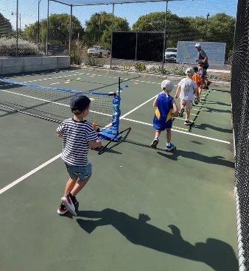

|  |
| --- |
| WEDNESDAY MORNING SOCIAL |

Wednesday mornings are humming along, with good turnouts of +20 players, with a good mix of skill levels.

Registrations 8.30am and start time at 9am, with four half hour matches and morning tea after the third match.

Need a bit of exercise in the morning and social interaction, come and join us.

|  |
| --- |
| PICKLEBALL - – Report by Ben Bevan - - see Jeremy’s images released with newsletter |

The inaugural South West Pickleball Showdown was held at the Busselton Tennis Centre on Sunday (23rd Feb 2025).

64 Players competed in the competition, in Intermediate and Advanced divisions. With 32 from Bunbury Pickleball Inc taking on 32 from Pickleball Busselton Tennis Club.

The players took part in 128 games, playing for the coveted ‘South West Pickleball Showdown’ Trophy.  The winning city being decided by total aggregate points across all games.

Top teams also played off for Gold, Silver and Bronze in each division.

The Picklers of the Bunbury Pickleball club were so strong they took out all medals on offer – claiming Gold, Silver and Bronze in both divisions, winning 930 to 588.

Bunbury Pickleball Inc. Chairperson, Nathan Papas said “It has been a great day, the team at Busselton have organised a wonderful event. It’s been so much fun, nice to see more than 60 players, plus spectators and volunteers down at the Tennis club having a great time”

On being asked if the Showdown will continue, Nathan said “We’ve got a Trophy on the line now, so this is definitely an annual event, I was actually thinking that it could be a 6 monthly, twice a year event. Everyone is having such a wonderful time it has to be a more regular occurrence.

Ben Beven of Pickleball Busselton Tennis Club, organiser and player at the Showdown said “It was a great day with 64 players competing. In the end Bunbury were the victors convincingly over Busselton. Congratulations to Bunbury – until next time”.

GENERAL PICKLEBALL NEWS

Pickleball Busselton Tennis Club welcomes new players to come down and try Pickleball. The club provides all equipment and teaches new players the rules and how to play.

Pickleball is played at the Busselton Tennis Club 4 times a week – Tuesday, Thursday and Friday evenings at 6pm. And Saturday mornings at 9am. Search ‘Pickleball Busselton Tennis Club’ on Facebook ([Busselton Pickleball Tennis Club](https://www.facebook.com/profile.php?id=61567036333650)) for details on how to get involved. Email [pickleball.busselton@gmail.com](mailto:pickleball.busselton@gmail.com)

Also worth a mention - the WA State Championships were played across Jan 31st to Feb 3rd, Pickleball Busso Tennis club players represented - with a number of medals being picked up. Congratulations medallists. [Photos of event](https://www.dropbox.com/scl/fo/jk3h8xiekxawxr5xqp0g5/AAdZnxfSvjK2eJJRInlIKxM?rlkey=tlczbbn7z8suyroetnbwo9cfd&st=utjcuwhl&dl=0)

PICKLEBALL ADMIN REPORT

The Pickleball Fraternity have asked the management committee of Busselton Tennis Club to include same as a part of the Tennis Club. This would include having Constitutional By Laws voted on by a majority of Tennis Club Members accepting the Pickleball Group as members in their own right and with descriptions of their membership. A Pickleball Membership fee would be struck once all is agreed upon. As with BTC, fees would be paid annually and set at an amount which would include court play fees.

Information will be shared as it comes to hand, chat to Ken if you have questions [Treasurer@busseltontennisclub.com.au](mailto:Treasurer@busseltontennisclub.com.au)

|  |
| --- |
| JUNIORS - see Jeremy’s images released with newsletter |

‘HAH FRIDAY’ RETURNED WITH A SMASH!

The Busselton Tennis Club was buzzing with energy on Friday, 14th February, as HAH Friday made its much-anticipated return for 2025. More than 60 enthusiastic young players, along with their parents, gathered at the club for an afternoon of tennis, fun, and community spirit.

With perfect weather setting the stage, the courts were alive with activity as juniors showcased their skills and enjoyed the camaraderie of their friends. Parents soaked up the club’s warm hospitality with drinks on the verandah, creating a fantastic atmosphere that highlighted the spirit of our tennis community.

A huge thank you to all the volunteers who made the afternoon a great success. Your dedication ensures that events like HAH Friday continue to thrive. We look forward to seeing even more players on court in the coming weeks.

JUNIOR TOURNAMENT – See Jeremy’s images released with newsletter

Held from January 26th to 29th at the Busselton Tennis Club, showcased emerging tennis talents across various age divisions. The tournament featured both J250 and J125 level events, attracting a competitive field of junior players. Also included was an Under 10 Green Ball event. This addition provided a platform for younger players to experience competitive play in a supportive environment.

**Age Divisions:** 10 and Under (10U) 12 and Under (12U)- 14 and Under (14U)- 16 and Under (16U) with 8 players participating. See Coaches Corner for list of local participants.

The tournament was well-organized, with matches commencing early each day to accommodate the full schedule. The semi-finals took place on January 28, leading to the finals on January 29. All grass courts and four hard courts at the Club were utilized to ensure smooth progression of matches. The event not only provided a platform for young athletes to compete but also fostered sportsmanship and community engagement.

Participants, coaches, and spectators praised the high level of competition and the club's excellent facilities.

The event attracted **129 participants**, their families, & supporters from interstate many regions throughout WA.

Overall, the Busselton Junior Tournament was a resounding success and cannot be achieved without volunteer’s support. We would like to thank all of the members who contribute by donating food, baking cakes and biscuits and those who volunteer in the kitchen, our court marshals, bar team and grounds.

SOUTHWEST REGIONAL JUNIOR TOURNAMENT – NEW INITIATIVE

The Busselton Tennis Club is proud to host this inaugural Tournament on Sunday, March 23rd. This exciting event promises to bring together some of the region’s most talented junior players for a day of thrilling matches & friendly competition.

The tournament will feature singles and doubles for 12 and under juniors, providing an excellent opportunity for our young players to showcase their skills. Matches will kick off early Sunday morning, with the finals scheduled for the late afternoon.

Food and refreshments will be available to competitors throughout the day.

Volunteers are needed to help make this event a success. If you’d like to assist with court setup, scoring, or in the clubhouse, please contact the Junior Club Coordinator Graeme Bracken.

Let’s come together as a community to support our junior players and celebrate the spirit

of tennis. Spectators are welcome, we look forward to seeing you there.

|  |
| --- |
| THE A TEAM, THE B TEAM AND GARDENING GURU’S |

A TEAM – have been busy recovering courts from Junior tournament and preparing courts for March tournament.

NO NET NO PLAY is still to be observed by all members. Chris is doing his best to provide grass courts for members for all events, let’s be mindful that we may from time to time have to use hardcourts.

B TEAM – have been busy “being” in the gardens with general tidy ups and smashing out those weeds which are never ending. If you are walking past our gardens and facilities and see a weed begging for the bin do just that!

They have also “fixed” the water cooler on the west verandah, put up and removed shade between the hard and grass courts for the junior tournament, returned chairs to club during tournament, and assisted with banners etc.

The B Team are always looking to build their crew, many hands make light work. Have a chat to Dennis Schram if you can support this important team. Thanks to this crew for all you do for our events and our members.

|  |
| --- |
| **LETS GET SOCIAL ….. LET’S SUPPORT THESE EVENTS ….** |

At Busselton Tennis Club we blessed to have members who are prepared to work together and offer us social engagement and “fun tickets”.

These events offer opportunity to enjoy ourselves and importantly another fund-raising avenue that benefits all club members. So please, if you can support these events by attending, putting your hand up to help coordinate vents or contribute in another way such as donations, please do.

Do note we are always on the lookout for donations suitable for raffles as these of course generate another stream of income.



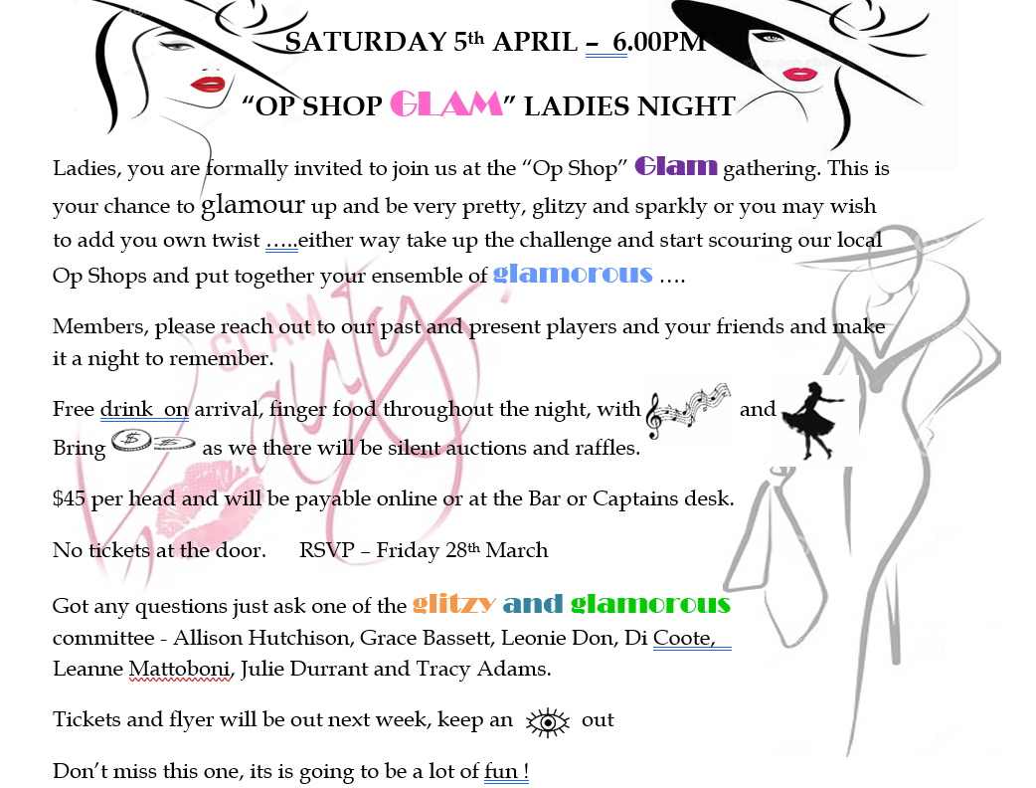

|  |
| --- |
| **SPONSORS’ CORPORATE DAY – “DOUBLE THE FUN” - 7 FEB 2025 – REPORT BY TARRYN SULLIVAN – EVENT COODINATOR**  **(**see Jeremy’s images released with newsletter) |



This event is hosted annually by the Tennis Club in recognition of the valuable support and contribution provided to the Club and its members by its Sponsors. A private event inviting Sponsors and their guests to participate in an afternoon/evening of tennis, social entertainment, networking and fun.

This year, the format was changed to include two segments, tennis and lawn bowls. What a great idea! This resulted in what I would say, and confirmed by many, as the “best” Corporate Day yet. A major contributor to the day’s success was thanks to Cliff Silke (CD Drilling) who not only organised the tennis tunes and bowling beats during the day but also generously provided the liquid refreshments during the bowling segment which Chris Ashton (Greenkeeper) and side-kick Graeme Watson “Watto” served on court by tractor. This was well received by all and perhaps contributed somewhat to Ian McLeod’s bowling technique, which saw bowls go everywhere but near the jack!

The day was social and fun; there was no competition. Anyone could play. 70 people attended including 17 sponsors and those club volunteers, who worked tirelessly in the bar, kitchen, taking photographs and collecting raffle money. 32 players graced the courts to play three sets in the afternoon sun. After a short 30 mins refreshments break, another 32 returned to the grass to play lawn bowls on Courts 4-7. It was great to see so many sponsors and non-playing tennis members participating and just having fun. A big thank you to Marty and Paul Collins for organising the lawn bowls and to Yves De Roche and Gus Guthrie (Makit Hardware) for helping to manage the eight “Sponsor” teams. Although no competition, names of participating segment players were put into a hat and drawn later in the evening. Draw winners: Lawn Bowls - Sue Maccora (Magnum, Robert Oatley Cabernet Sauvignon) and Tennis, Sandy Sigelski, Sandy Bay Holiday Park (Two bottles of wine).

I would like to thank all the Sponsors who attended. Your continued support of this event, the Club, its members and our great facilities is truly appreciated. I also take the opportunity to acknowledge those club volunteers that help make this Day successful. Without you, I could not run this event. Huge thanks goes to:

* Allison and her catering team. The refreshments and finger food excellent. A big thank you to Sponsor, Tori Sushi (Richard) for providing the tasty sushi platters.
* Cate, Wayne and Graeme for serving drinks throughout the day and Approved Bar Manager, Ken Madden. As usual, Court 28 was humming.
* Extra thanks to Cate and Graeme, who also helped me with getting the clubhouse ready on Friday and to Cate for helping put everything back in order for Saturday social.
* Big thank you to Glen Young and niece, Lisa for providing the evening’s entertainment. What a way to end the evening; sitting on the veranda with friends, drink in hand, listening to live music. Glen, your support and contribution at this event is always appreciated.
* Junee MacDonald and Grace Bassett for managing ticket sales. You raised $405! This year, six great prizes donated by Sponsors *(winners noted in brackets)*: Busselton Toyota – Service Voucher *(Cate Muntz),* The Esplanade – Giftcard *(Cliff Silke),* Tennis South West – Coaching Voucher *(Kelly Bunney, Bendigo Bank)*, 1.5L Robert Oatley Cab Sauv *(Ian McLeod),* ON-Q Projects – Flying Fish Cove Sparkling Pinot Noir Chardonnay *(Vicky, catering team member)* and Kim’s Garden – Plant Display *(Ken Madden).*
* Jeremy for taking the photographs (please see [BTC’s FaceBook](https://www.facebook.com/busseltontennisclub) page).
* Finally, Chris Ashton and the A Team. The grass courts were, as always, fantastic. We certainly have the best facilities here in the South West. Thank you for all your hard work throughout the season.

|  |
| --- |
| 2025 TENNIS SENIORS AUSTRALIA NATIONAL TEAMS CARNIVAL - WRAP UP - WANT TO PLAY NEXT YEAR - WHY NOT |

There has been a lot of chat generated from WA’s success at the 2025 Tennis Seniors Australia National Teams Carnival held in Jan in Adelaide. Is the closing wrap, you will see that WA was very successful. Do you wish to be part of this event next year? If so take a look at this link [Australian Teams Carnival and Individual Championships – Gold Coast 2026](https://play.tennis.com.au/tennisseniorsact/KeyTournaments/TeamsCarnival). It is suggested if you are considering participating in this event that you seek out accommodation early.

|  |  |  |
| --- | --- | --- |
| WA 33 - teams (203 players) | SA - 23 teams – home state | Victoria – 17 teams |
| Queensland – 16 teams | NSW – 15 teams | ACT – 11 teams |
| New Zealand – 2 teams | Malaysia – 1 team |  |

Of WA’s 33 teams, we were successful in winning 4 GOLD medals.  Winning teams were: (Teams in bold had local representation from Busselton or Dunsborough) Winning teams and respective Captains

**WA W60 5       Debra   Kirk. WA W60 2      Tracy    Adams. WA M70 2      Kevin    Dingle.**

In addition, WA were Runners Up in 4 divisions:

**WA W70 2-   Wendy Weir. WA W60 1- Kymm Sweeting WA M80-   Garry  McDonald** WA M60 1-   Shane  Smedley

[Team Lists, Draws, fixtures and full results of Adelaide event](https://www.92computing.com.au/teamdraw25.pdf)

The ITF MT1000 (individual events) saw the following West Aussies with a podium finish

* Winner s - Cameron Norsworthy; MS40 and Bobbie Edwards WS85
* Runners Up - Brett Patten –MD50; John Holland & Shane Smedley - MD60; Bobbie Edwards - WD80

**Have you chosen to participate in our discounted membership option and have yet to complete your obligation?**

**Could you assist Graeme with Have Hit Fridays, just a couple of hours would be amazing!**

**Have a Hit Fridays targets young families and is one of our showcase programs, the kids get to have fun, the adults get mingle, enjoy our facilities and of course sing our praises. Please help 😊**

|  |
| --- |
| **CLUB CALENDAR – SAVE THESE DATES** |

* **Have a Hit Fridays has resumed**
* **Mixed Thursday Nights has resumed**
* **Tuesday Night social has resumed**
* **28th Feb – 3rd March - March Tournament**
* **8th March – club closed for private function**
* **9th March – Sunday social tennis in lieu of 8th March**
* **15th March – St Patricks day Irish dinner – see flyer in newsletter for details**
* **15th & 16th March – Mixed Doubles Championships (Sat 15th will only be used if numbers demand)**
* **20th March – Southwest League Ladies Pennants grand final**
* **22nd & 23rd March - Singles Championships (Sat 22nd will only be used if numbers demand)**
* **23rd March – Southwest Regional Junior Tournament**
* **27th March – 31st March – Bomaderry NSW visiting**
* **5th April – Ladies – Op Shop Soiree – see flyer in newsletter for details**
* **1st - 29th May – Sanderson Women’s Competition starts**
* **10TH May – AGM**

***Busselton Tennis Club members appreciate our Sponsors***

***who have invested in our vision and activities.***

***We encourage our members to acknowledge and support***

***our Sponsors whenever possible.***

