**EDITION 8**

**Hello to you …..**

**Court 28 News shares important information with our membership group. Thanks to those who have contributed reports and images or were involved with the publication.**

**Our official tennis season is drawing to a close. We have hosted many successful events, functions, and gatherings**

**Have A Hit Fridays has showcased our club and been a season highlight. Great to see the kids and the adults on the court making memories and mingling socially.**

**Our Corporate Day was another opportunity to showcase our club’s hospitality and professionalism, also allowing us to express our gratitude for their support.**

**And Pickleball, Wow! We have 192 members registered in the Pickleball Stack App “chat group”, of which 60 are Social members. This sport is trending worldwide. When are you going to try Pickleball?**

|  |
| --- |
| **PRESIDENTS REPORT** |

The official financial year for the B.T.C. Tennis season has ended on the 31st of March. With that in mind the A.G.M. is very soon on the 10th of May 2025 I encourage members to have a long think about being involved on the management committee as there are a number of current members stepping down.

Vacancies are President, Captain, Sponsorship, and Communications. A nomination sheet will be placed on the notice board in the coming days, so seriously consider being an applicant for a position as it makes it very difficult if these positions are not filled for the smooth running of the B.T.C.

Please attend the A.G.M. as a club we will discuss the pro’s and con’s of the Squash Club being constructed and linked to the B.T.C. This will be one of the most important decisions since the formation of the new club.

The Squash Club and the City Council will be asked to talk on the possible location of the Squash Club.

I think most of the members are aware of the issues that Ken Madden is facing at the moment and in the future, we wish him the best possible outcome. Ken and Wendy have expressed their gratitude for your care and support.

As I am finishing my term as President at the A.G.M. I wish the incoming Management all the best for the coming year and would like to thank everyone for their help in the Management Committee, but above all, the terrific voluntary support that is in this great club, that is the main reason that this club is so successful.

Wayne - President

|  |
| --- |
| **GENERAL CLUB NEWS** |

BOMADERRY / BERRY VISIT TO BUSSELTON TENNIS CLUB

Busselton Tennis Club hosted and billeted 13 players from Bomadeerry / Berry (NSW) between 27th March -1st April. This is a reciprocal event coordinated by Yves. Last year, our lads had a great visit but did not bring back the “Cup”.

We are pleased to advise Busso were victorious this time, holding both the Ladies and Men's Cups. And yes, we will be trudging across the borders to defend our Title next year.

Our visitors saw plenty of the tennis court with social and competitive games and engaged in many tourist-based activities.

They were amazed by our club hospitality and facilities, were envious of our grass courts, and grew to be quite comfortable at Court 28.

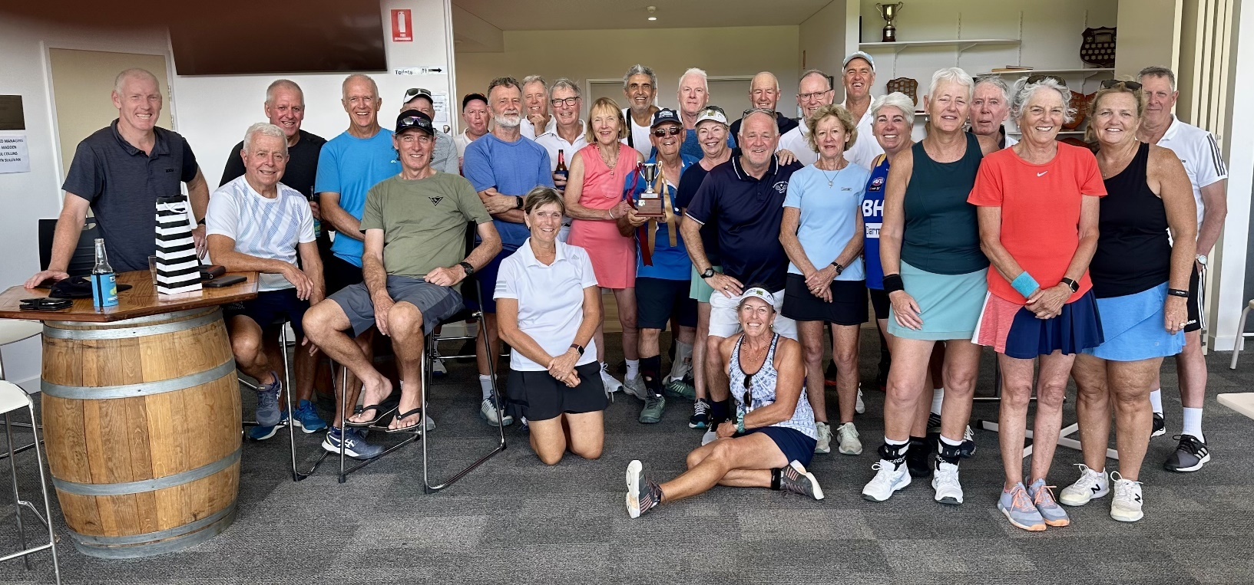

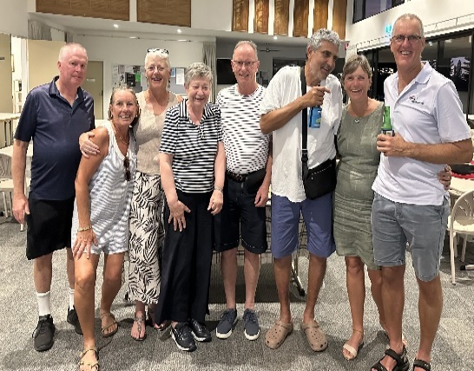

OP SHOP GLAM – 9TH May, 2025

** Are you still thinking about joining the Op Shop Glam night out?

SAY YES! WHY NOT!

Take that break from your “grown-up” responsibilities, get out of the kitchen, fulfill that thought of spending time with your friends… life is busy right 😊

 Details - **2025 Op Shop Glam night at 6pm, Friday, 9th May, Busselton Tennis Club!**

This is not our first Op Shop Junket; we have done this before and well, we must say we did it very well if we are judging by the joyous smiles and fun tickets had by all.  Check us out on either image link to website or the attached images

 Dress in your most glamorous Op Shop outfit. There are no rules - tiaras or sparkly sneakers all fit the bill!

 Enjoy sipping on complimentary sparkling French bubbles as you step off the red carpet, relish delightful finger foods, and take the opportunity to mix n mingle with the BTC Tennis Club girls and their guests who wanna have fun!.

So why not “bop and shimmer” to the tunes and participate, if you choose, in fun activities? You can sparkle and shine in the photo booth as we capture your glitz! Of course, we will be awarding Best Dressed, have lucky door prizes, and have some other bits n bobs to keep you on your toes!!

 Come you, come your friends, the more the merrier. Get together for an unforgettable night.

 Proceeds raised will be channeled to support and encourage “Women in Tennis.” we are looking at the “how.“

 Snag your $45 tickets HERE <https://www.busseltontennisclub.com.au/op-shop-glam>.

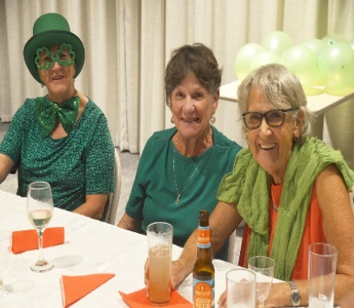 Any questions? Just shoot them over to [functions@busseltontennisclub.com.au](mailto:functions@busseltontennisclub.com.au)!

IRISH NIGHT CELEBRATION

Irish night 16th March 2025

"There are good ships and there are ships,

The ships that sail the sea. But the best ships are

friendships, And may they “always be"

'To be sure' ... 'To be sure' …BTC St Patrick's Day celebration, twas “craic” abundant with friendship and frivolity, with reminded us all just how much Busselton Tennis Club draws us all together in celebration. Kudos to Katherine O’Connor for her efforts in coordinating and cooking for the event.

CLUB MANAGEMENT COMMITTEE does its best to communicate club events via emails from “Club News”, Court 28 News (Newsletter), Club Calendar, Social Media, Website, announcements and the Noticeboard.

|  |
| --- |
| **CAPTAINS REPORT** |



CLUB CHAMPIONSHIP RESULTS

MENS SINGLES EVENT

Championship – Myles Armstrong defeated Bryce Godfrey 6/1 6/1

Plate – Dave Triffit defeated Glen Tuffin

Over 65s – John Mc Callum defeated Rob Preston in a tie break set

MIXED DOUBLES EVENTS

Championship - Bryce Godfrey & Krista Sanderson defeated Calum Macauley and Stefi Windsor

Plate – Zeleika Cahil and Sean Allardyce All

Over 65s – Greg Hooper and Sandy Selieski

Congratulations to all competitors and winners of events

CLUB CHAMPIONSHIPS AND HANDICAP EVENTS: To play in these events, you must be a financial member of Busselton Tennis Club for at least 1 month prior to the event and you must enter prior to closing date of event. It is up to players to check their times of play and take the on-court to commence play at the designated time.

EASTER SATURDAY – 19TH APRIL 2025: Social Tennis, Prize for best dressed, Easter Raffle, a light evening meal offered for $10.00 per person. For catering purposes, names must be in no later than Wednesday, 16th April.

WEMBLEY DOWNS VISIT: Wembley Downs players will be visiting BTC on Saturday 24th May. Come on down and meet the Wembley Downs crew, play n stay for a light evening meal.

WANTED – A member to volunteer to liaise with the Functions coordinator and Club Contract cleaner (Tracy Cottam) for next season. Duties include buying cleaning products and checking bathrooms during the week.

SOUTH WEST LADIES LEAGUE – Congratulations to all teams that made the finals. We all look forward to a new season come October.

Commitment and practice- both these words boost team spirit and put forward a competitive team each week.

After all, we are all there to enjoy the tennis, the interactions with our team members.

|  |
| --- |
| **CLUB CALENDAR - PLEASE NOTE YOUR DIARY** |

* **27th March – 31st March – Bomaderry NSW visiting**
* **10th April – Southwest Ladies League Grand final in Bunbury**
* **19th April – Easter Saturday – Social / Raffles and dinner**
* **9th May – Ladies – Op Shop Glam evening**
* **24TH May – Wembley Downs Visit**
* **1st - 29th May – Sanderson Women’s Competition starts**
* **10TH May AGM**

|  |
| --- |
| **MEMBERSHIP** |

Discounted Membership - Did you elect to take the discounted members option and offer your Volunteer Support to our club?

Has life got in the way during the season, and you have not yet fulfilled your obligations?

It’s all good, there is time and many Volunteer options for you to participate in and tick the job done box! For example, an easy one is ladies on Arvo tea roster are calling for additional support on a Saturday.

If that’s not for you Rob Lennox our Volunteer Coordinator will be happy to assist you in meeting your obligations. just give him a call at 0413932800. He will offer options/opportunities or alternative solutions.



|  |
| --- |
| **SOUTHWEST LADIES LEAGUE REPORT** |

We certainly have endured warm weather at the beginning of this year and has indeed made it a tough season for all.

March 27th saw scheduled matches for 2024/25 completed.

**Division 1**

Kookaburras (captain Jodie Ganzer) team finished 3rd on the ladder and played Dunsborough Dashers last week. Kookaburras won 7 sets (56 games) to Dasher 5 sets (58 games) and will travel to and play Bunbury Thursday 10th April in the Grandfinal

Possums (captain Deanne Smith) team finished 4th on the ladder, played and were defeated by Bunbury

**Division 2**

Quokkas (captain Lisa Wake) finished 3rd on the ladder, played in Donnybrook, and were defeated

Bandicoots (captain Grace Bassett) finished 4th on the ladder and in Australind Backhanders in Australind and were defeated

**Division 3**

Penguins (captain Julie Durrant) finished 5th on the ladder (out of 8 teams) A great effort, ladies.

Thank you so much to all of the captains throughout the season you have done an amazing job and especially when injuries and other circumstances make it difficult some weeks to field a team.

I, Michelle will be stepping down from the Coordinator role, I am looking for someone to come forward to take over SW League Co-ordinator for Busselton Tennis Club.

I am happy to assist you with the transition and be on the selection committee for next season.  The role does require some time at the beginning and end of the season.  You will be required to attend a couple of meetings in the year for the zone representing the club.  Please feel free to contact me on 0421 762 437 or email [mvdkroft@live.com.au](mailto:mvdkroft@live.com.au) if you have any questions or would like to consider taking over the role.

Hope to see you at the finals in Bunbury and on the tennis courts! Michelle

|  |
| --- |
| **South West League players – should you wish to continue to hit Thursday morning, we will need to find a coordinator. It will be a short-term role, pending the winter weather. Chat to Wendy or Merryl, who can assist.** |

|  |
| --- |
| TENNIS SOUTH WEST |

Busselton Tennis Club hosted the inaugural Regional Talent Series Sunday 23rd March 2025 for junior players.

This exciting event brought together some of the region’s most talented junior players for a day of thrilling matches & friendly competition.

The tournament featured singles and doubles for 12years and under juniors, provided an excellent opportunity for our young players to showcase their skills.

Two of our juniors were rewarded with a two-day camp in Perth with Tennis West, they will get to experience coaching and development with other juniors selected from other regions. (Please see pics below, Busselton Girls winner is Catrin Stenner & Busselton Boys runner up is Riley Mitchell).

We’d like to extend a big thank you to Graeme and all the club volunteers who made this day a great success!

Calum and Courtney

**THANK-YOU TO OUR SPONSORS**